Utilitarian distribution of scarce surgical capacity during the COVID-19 crisis: a comparative modelling study

Benjamin Gravesteijn* (0000-0001-8096-5803)1,2, Eline Krijkamp* (0000-0003-3970-2206)3,5, Jan van Busschbach (0000-0002-8602-0381)4,5, Geert Geleijnse (0000-0002-4718-0032) 1, Isabel Retel Helmrich (0000-0001-5257-395X)2, Sophie Bruinsma (0000-0003-3634-9899)y, Celine van Lint (0000-0002-7929-7622)y, Ernest van Veen (0000-0002-5495-3996)2, Jan van Saase (0000-0003-2874-6667) 6, Hester Lingsma (0000-0003-2063-9533)2, Rob Baatenburg de Jong (0000-0001-7236-264X)1, and the Value Based OR team collaborators**

*Both authors contributed equally

Author affiliations - Request all authors to check the affiliation + ORCID ID

# 1) Department of Otorhinolaryngology (ENT); 2) Department of Public Health; 3) Department of Epidemiology; 4) Department of Medical Psychology, 5) Netherlands Institute for Health Sciences; 6) Department of Internal Medicine; y) Department - Erasmus University Medical Center, Rotterdam, the Netherlands.

** Expert panel: Chris Bangma, Ivo Beetz, Patrick Bindels, Alexandra Brandt-Kerkhof, Danielle van Diepen, Clemens Dirven, T.W. Galema, Jeanette Goudzwaard, Mieke Hazes, Sjoerd Lagarde, Harmke Polinder-Bos, Eva Maria Roes, Hanneke Takkenberg, Mark van Vledder, *Rode pen zonder naam?*

# Abstract

## Purpose

COVID-19 has put unprecedented pressure on health care systems worldwide. This has led to a reduction of the health care capacity available for non-emergency surgical interventions. As a result, an accumulating group of patients is waiting for vital surgeries and societies face dilemmas about which patients should be prioritized. Therefore, our objective was to develop a decision model to estimate the effects of delay of surgical interventions on health and Quality of Life that can be used for prioritization.

Methods

A simple cohort state-transition model was developed to simulate the long-term implications of delaying surgery. We compared scenarios of delaying surgery from two weeks up to one year (with intervals of 10 weeks) and no surgery at all. Model parameterswere based on Dutch and American registries, literature, and the global burden of disease study by the World Health Organization. For each surgical indication, we estimated the average expected Quality-Adjusted-Life-Years (QALYs) for the different scenarios. Urgency was defined as expected health loss due to delay of surgery, expressed in QALY loss per month (QALY/month). A probabilistic sensitivity analysis was performed to incorporate parameter uncertainty in model estimates. The model was applied to 34 semi-elective (not necessarily performed within 3 days, but ideally performed within 3 weeks) surgeries on adults commonly performed in a Dutch academic hospital.

## Results

The maximum QALYs gained varied widely between procedures, from 0.54 (0.48 – 0.61) for resection of high-grade glioma to 10.3 QALYs (8.7 - 11.9) for kidney transplantation. The three most urgent interventions were surgically repairing an abdominal aneurysm of the aorta (-0.11 QALY/month, -0.13 – -0.09), pacemaker implantation (-0.11 QALY/month, -0.22 - -0.04), and the resection of cholangiocarcinoma (-0.09 QALY/month, -0.12 - -0.06). The three least urgent interventions were placing of a shunt for dialysis (-0.01 QALY/month, -0.01 – -0.005), resection of thyroid cancer (-0.01 QALY/month, -0.02 - -0.01), and resection of mild salivary gland carcinoma (-0.01 QALY/month, -0.03 - -0.01). Ranges are 95% confidence intervals.

## Conclusion

The expected health loss due to surgical delay could *reliably* be quantified with our decision model and can guide prioritization of surgical care from a utilitarian perspective (i.e. minimizing health loss for the total population) in times of scarcity. Placing this tool in the context of different ethical perspectives and combining it with capacity management tools is key to achieve large-scale implementation.

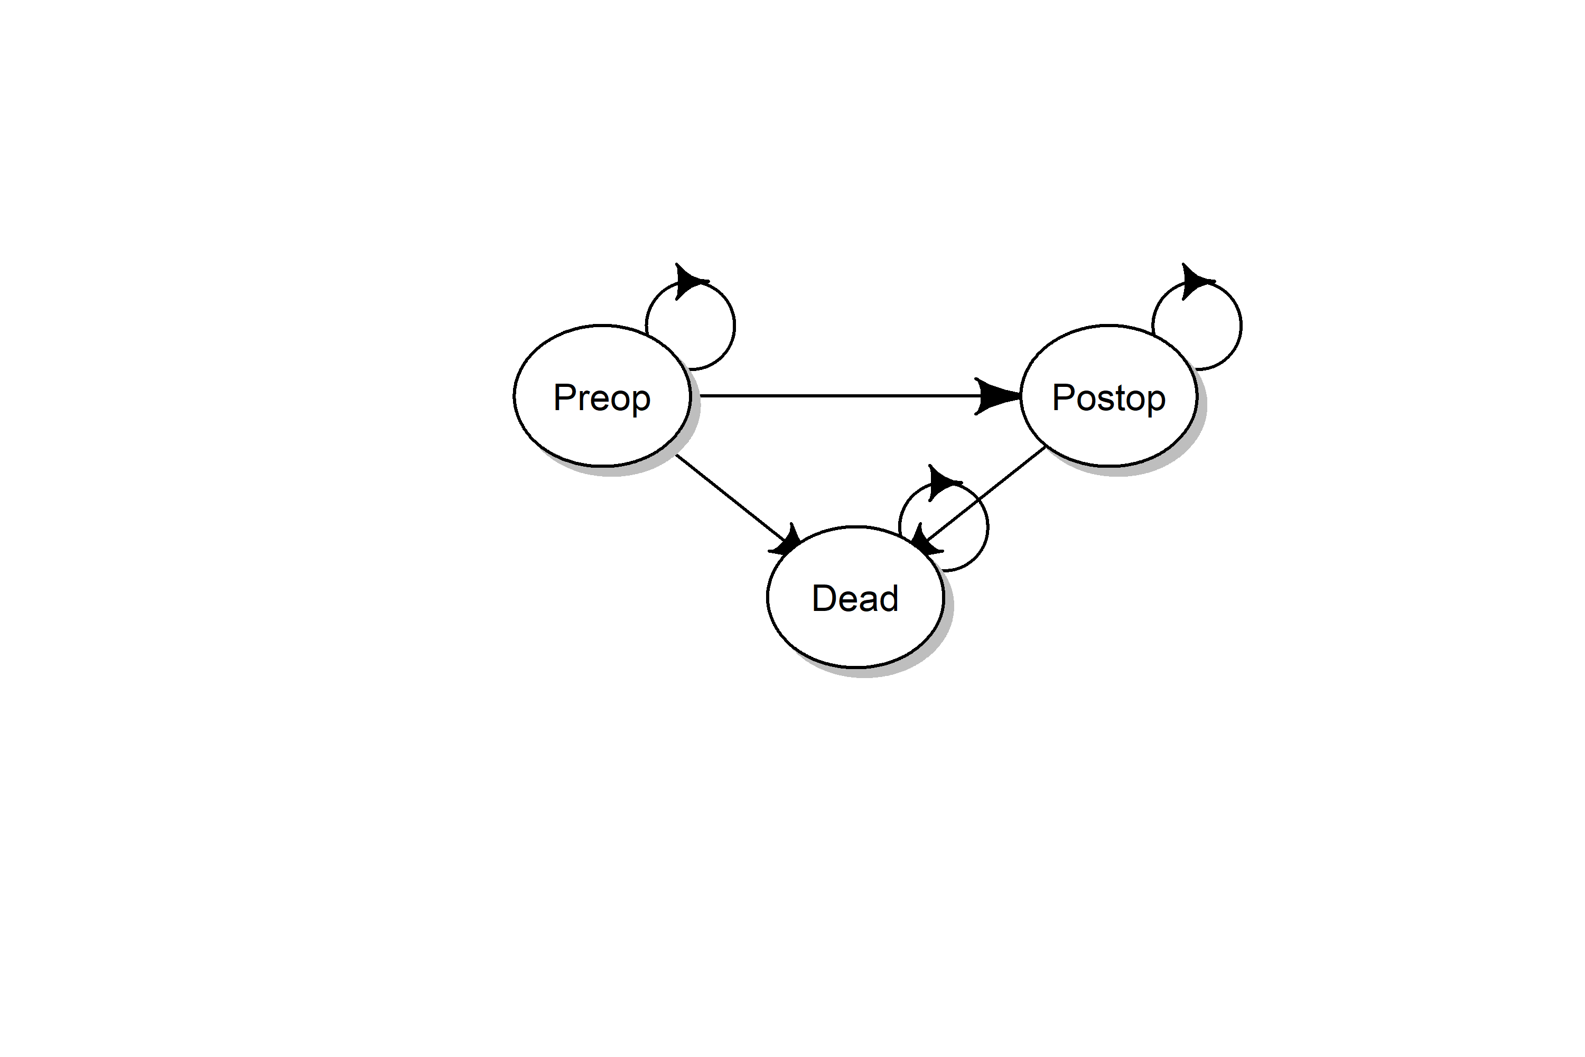

Figure 1, state-transition diagram of the model. The model is a Markov model consisting of three states: a preoperative state (Preop), a postoperative state (Postop), and the absorbing state Dead. All patient eligible of semi-elective surgery start in the Preop health states. From the Preop states they can die, transition to dead, or continue to wait for their surgery. At the time of surgery, which is determined by the scenario analysis, all individuals still alive in the Preop health state transition to the Postop health state. The remaining lifetime the cohort is followed. They can die, transition for the Postop state to dead or stay alive in the Postop health state.

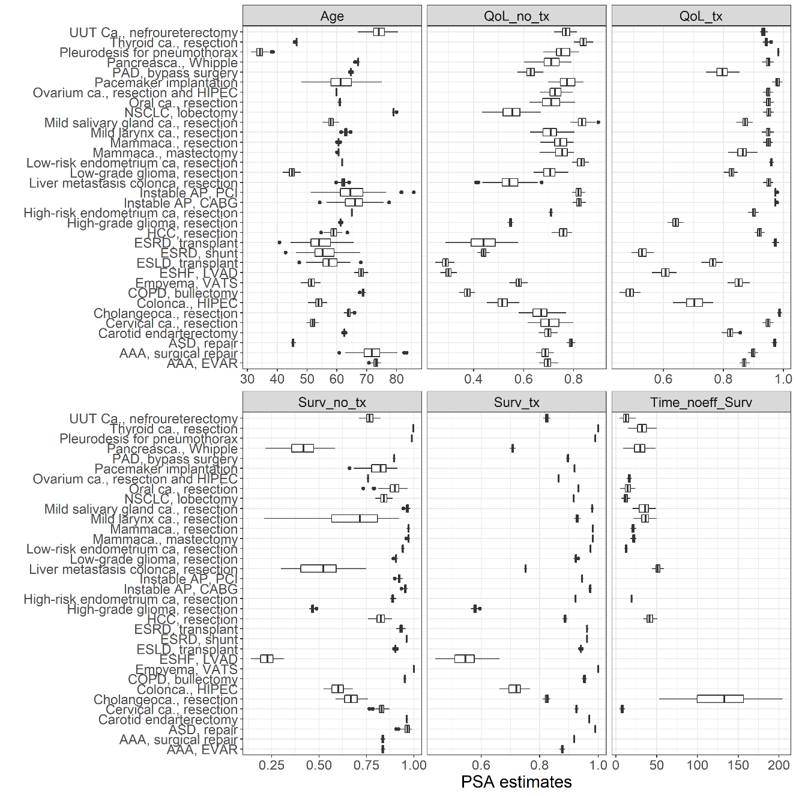

Figure 2, input parameters for the model. For a full list of input parameters per disease and source, see appendix A. Qol_no_tx: Quality of Life without treatment; QoL_tx: quality of life with treatment; Surv_no_tx: 1-year survival probability without treatment; Surv_tx: 1-year survival probability with treatment; Time_noeff_surv: days until no treatment is effective. ESRD: end-stage renal disease; ASD: atrial septum defect; VATS: video assisted thoracoscopic surgery; ESLD: end-stage liver disease; AAA: aneurysm of the abdominal aorta; AP: angina pectoris; CABG: coronary artery bypass graft; PCI: percutaneous coronary intervention; NSCLC: non-small cell lung carcinoma; EVAR: endovascular aortic repair; ca.: carcinoma; PAD: peripheral arterial disease; HCC: hepatocellular carcinoma; ESHF: end-stage heart failure; HIPEC: hyperthermic intraperitoneal chemotherapy.

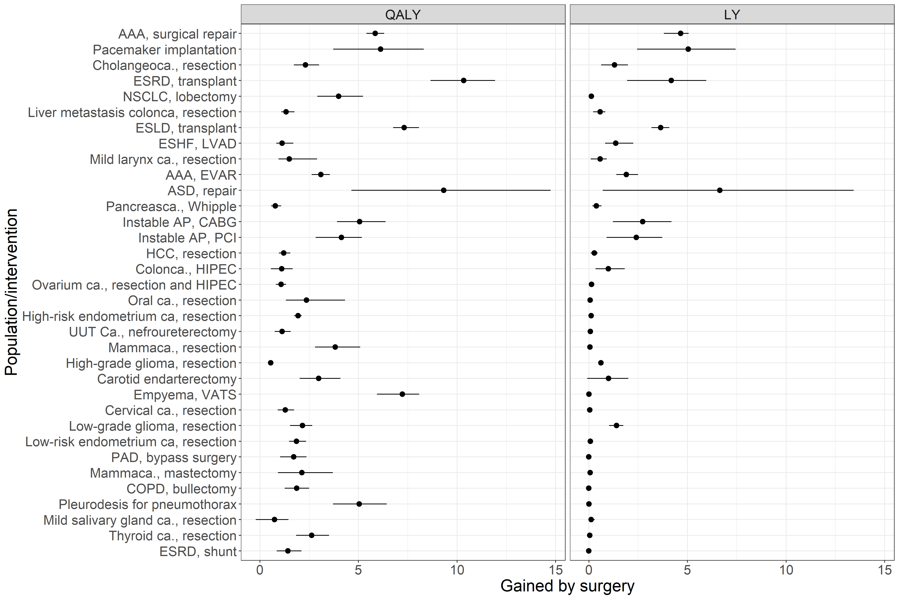

Figure 3, the maximum expected QALYs and LYs per intervention, in descending order of urgency (see figure 4). The estimates and 95% confidence intervals are shown. The model output for no surgery was subtracted from the model output for a delay of 2 weeks. The actual data are presented in appendix B. ESRD: end-stage renal disease; ASD: atrial septum defect; VATS: video assisted thoracoscopic surgery; ESLD: end-stage liver disease; AAA: aneurysm of the abdominal aorta; AP: angina pectoris; CABG: coronary artery bypass graft; PCI: percutaneous coronary intervention; NSCLC: non-small cell lung carcinoma; EVAR: endovascular aortic repair; ca.: carcinoma; PAD: peripheral arterial disease; HCC: hepatocellular carcinoma; ESHF: end-stage heart failure; HIPEC: hyperthermic intraperitoneal chemotherapy.

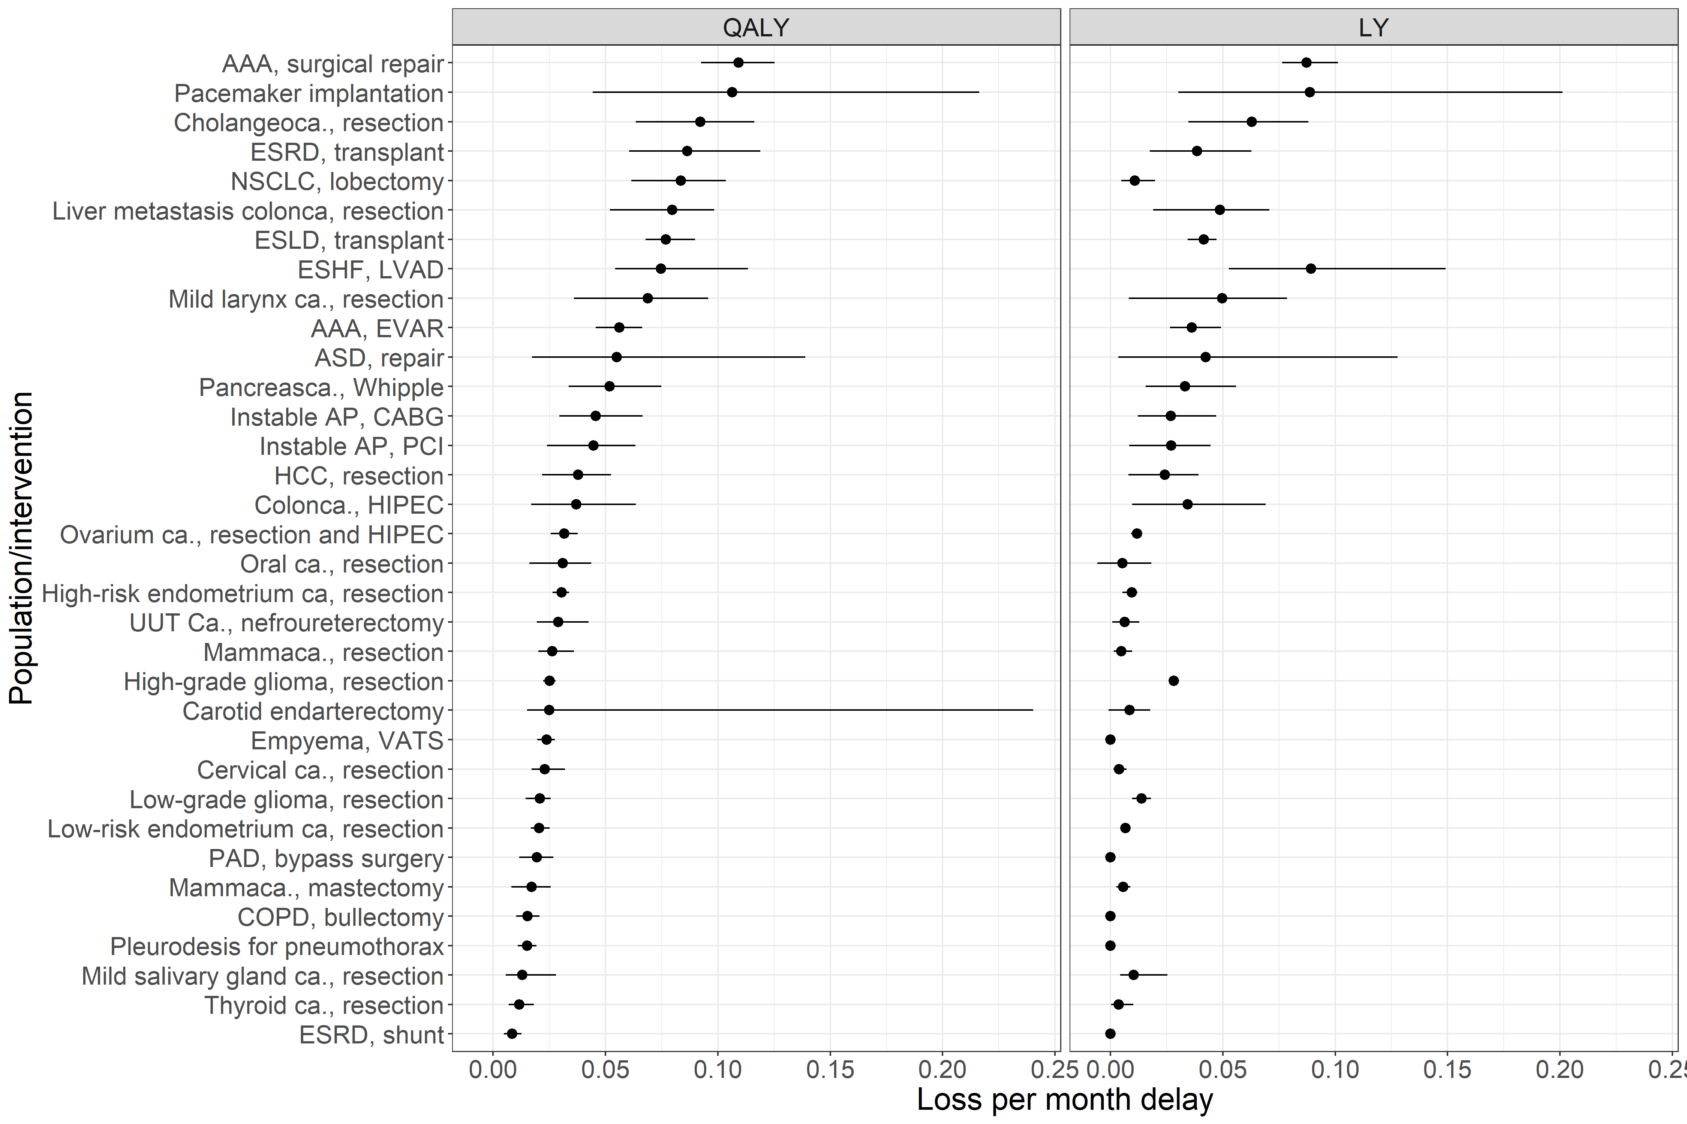

Figure 4, the average loss of QALYs and LYs per month of delay for the investigated interventions based on the simulation of surgery delay of 52 weeks. The estimates and 95% confidence intervals are shown. The actual data are presented in appendix B. ESRD: end-stage renal disease; ASD: atrial septum defect; VATS: video assisted thoracoscopic surgery; ESLD: end-stage liver disease; AAA: aneurysm of the abdominal aorta; AP: angina pectoris; CABG: coronary artery bypass graft; PCI: percutaneous coronary intervention; NSCLC: non-small cell lung carcinoma; EVAR: endovascular aortic repair; ca.: carcinoma; PAD: peripheral arterial disease; HCC: hepatocellular carcinoma; ESHF: end-stage heart failure; HIPEC: hyperthermic intraperitoneal chemotherapy.

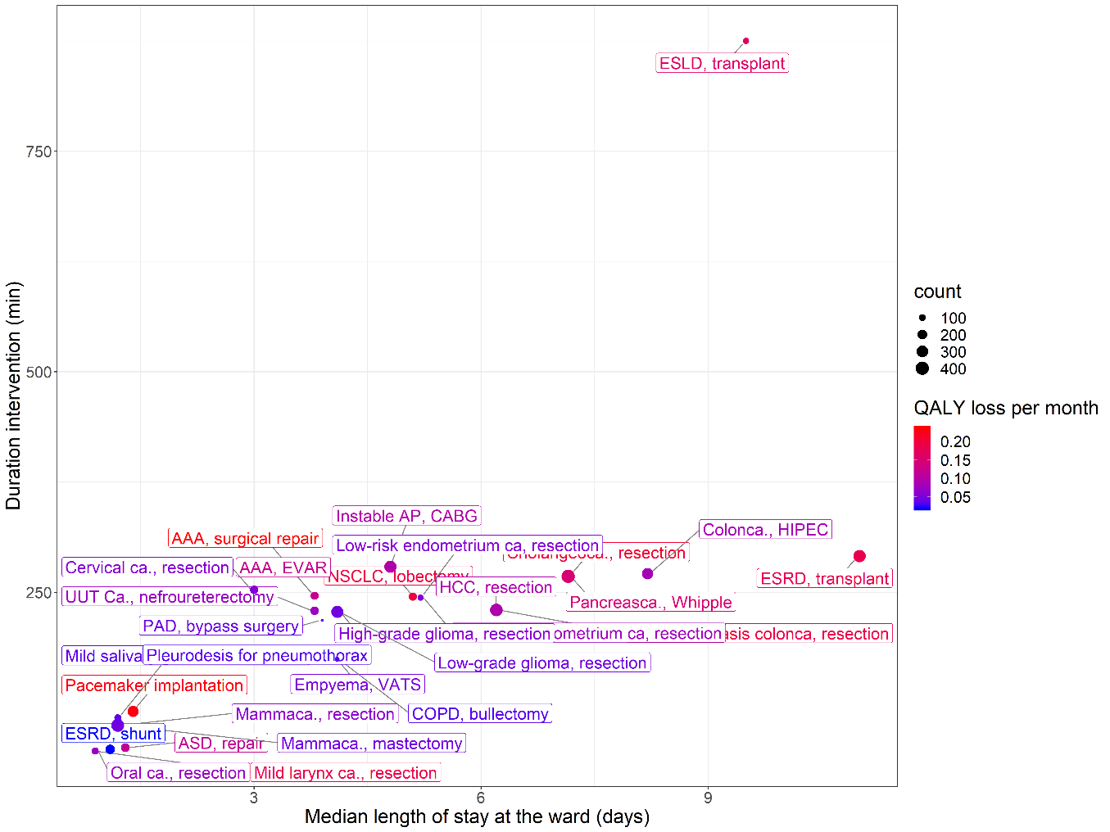

Figure 5, showing the mean duration of the intervention, the mean length of stay, and the frequency that interventions are performed in our hospital. The color coding represents their urgency in terms of QALY loss per week. The length of stay in days on the X-axis is the median length of stay within the hospital. This include both intensive care and non-intensive care stay. In Table 1, the length of stay is also showed separately for the ICU stay and non-ICU stay. ESRD: end-stage renal disease; ASD: atrial septum defect; VATS: video assisted thoracoscopic surgery; ESLD: end-stage liver disease; AAA: aneurysm of the abdominal aorta; AP: angina pectoris; CABG: coronary artery bypass graft; PCI: percutaneous coronary intervention; NSCLC: non-small cell lung carcinoma; EVAR: endovascular aortic repair; ca.: carcinoma; PAD: peripheral arterial disease; HCC: hepatocellular carcinoma; ESHF: end-stage heart failure; HIPEC: hyperthermic intraperitoneal chemotherapy.

## Disclosures

**ADD DISCLOSURES (Please add your personal disclosures!)**

Eline Krijkamp was supported by the Society for Medical Decision Making (SMDM) fellowship through a grant by the Gordon and Betty Moore Foundation (GBMF7853).

JVS, XX, XX report no personal disclosures

Acknowledgement **(Please add anyone we have to acknowledge here)**

We are grateful for H. Karreman and C. Van der Velden - van der Graaf for the work they have done for the quality of life data collection. Moreoever, we want to thank Ruben Goedhart for extracting the data from the electronic patient registry.